Outline Procedures Manual for Wingo’s site:

How to:

* Slider:
* How to update a slider:

1. Log in to your website (See “How to Log In”)
2. Go to the black sidebar (left)
3. Click on the Slider Revolution plugin
4. Next select which slider you wish to update

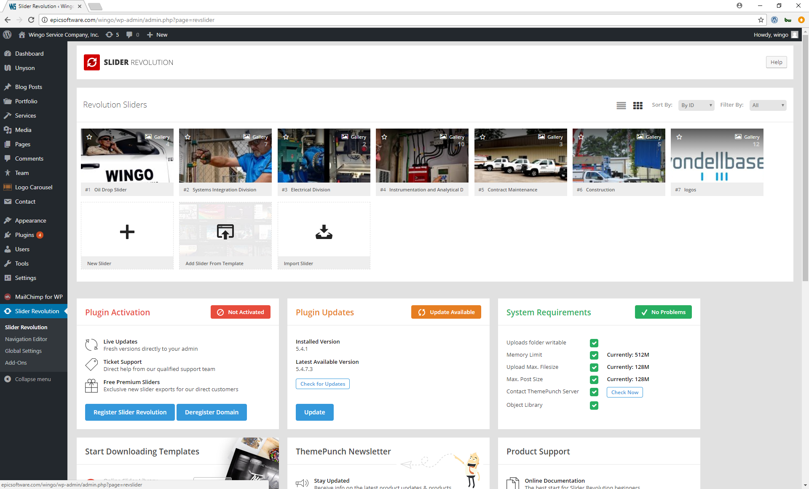

1. Click on the slide you want to update the background image
2. Then click on the button Media Library (red circle)

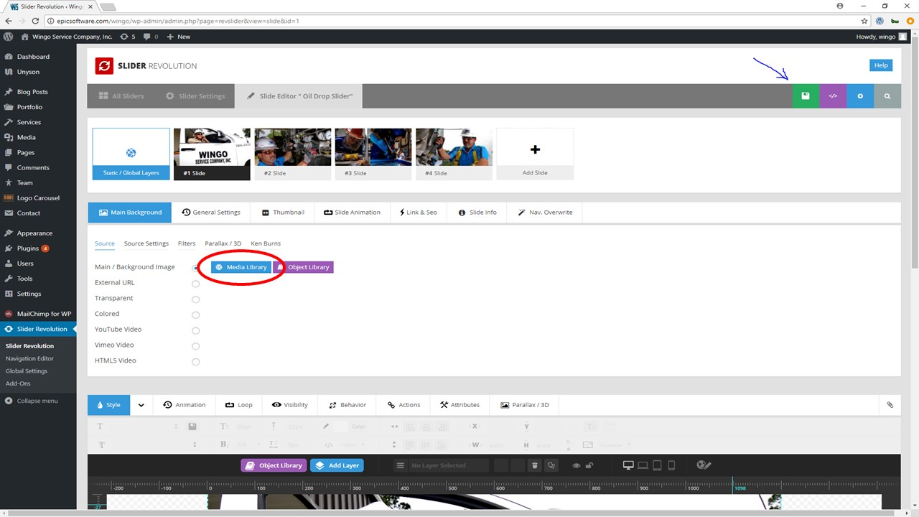

1. Upload an image with 1920 x 862 pixels (See “How to upload a picture” and “Importance of uploading the images with the right size”)
2. Click on the green box (see previous image) to save

* Change the order of the slides

1. Just drag and drop the slide to the position where you want it to be

* How to create another slide

1. Go to the slider you want to create a new slide (See “How to update a slider” steps 1-4)
2. Hover your mouse on any slide and click duplicate (See image and red circle)

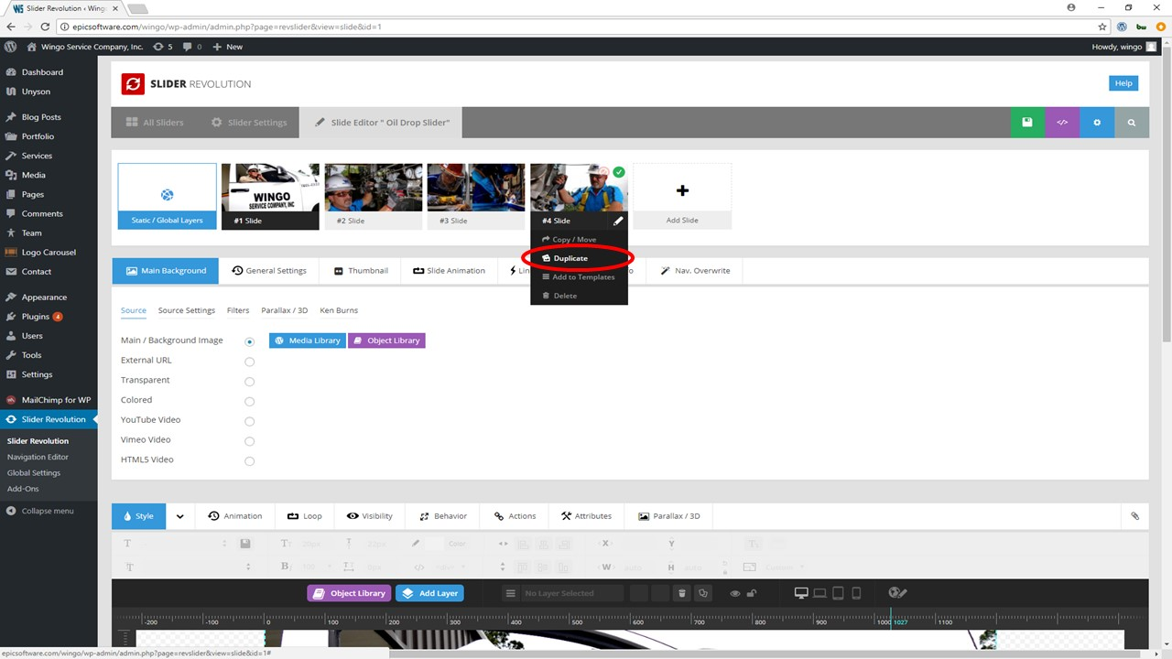

1. Then update the background image (See “How to update a slider” steps 5-8)

* Pages:
  + How to update any page

See the documentation provided by the theme (Customizer

-> How to use Unyson Page Builder)

(Ask about this)

* News Section
* How to create a new newsletter post for the site:

1. Log in to the website (See “How to log in”)
2. Go to the black sidebar (left)
3. Click on “Blog Post”

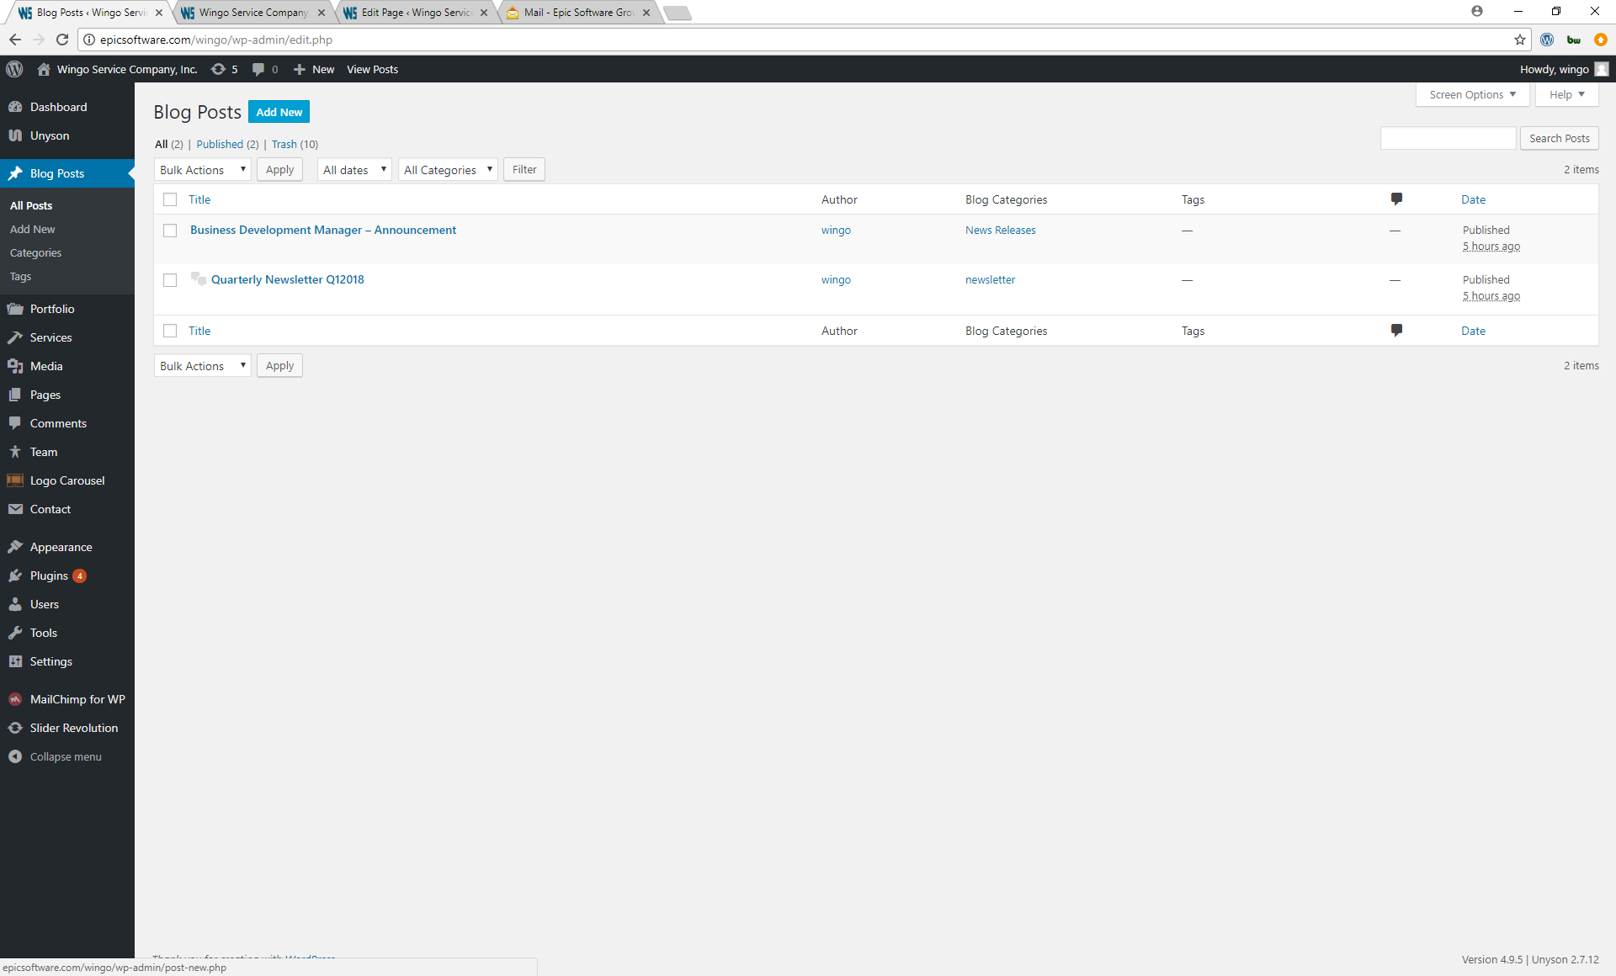

1. Click on “Add New” at the top of the page

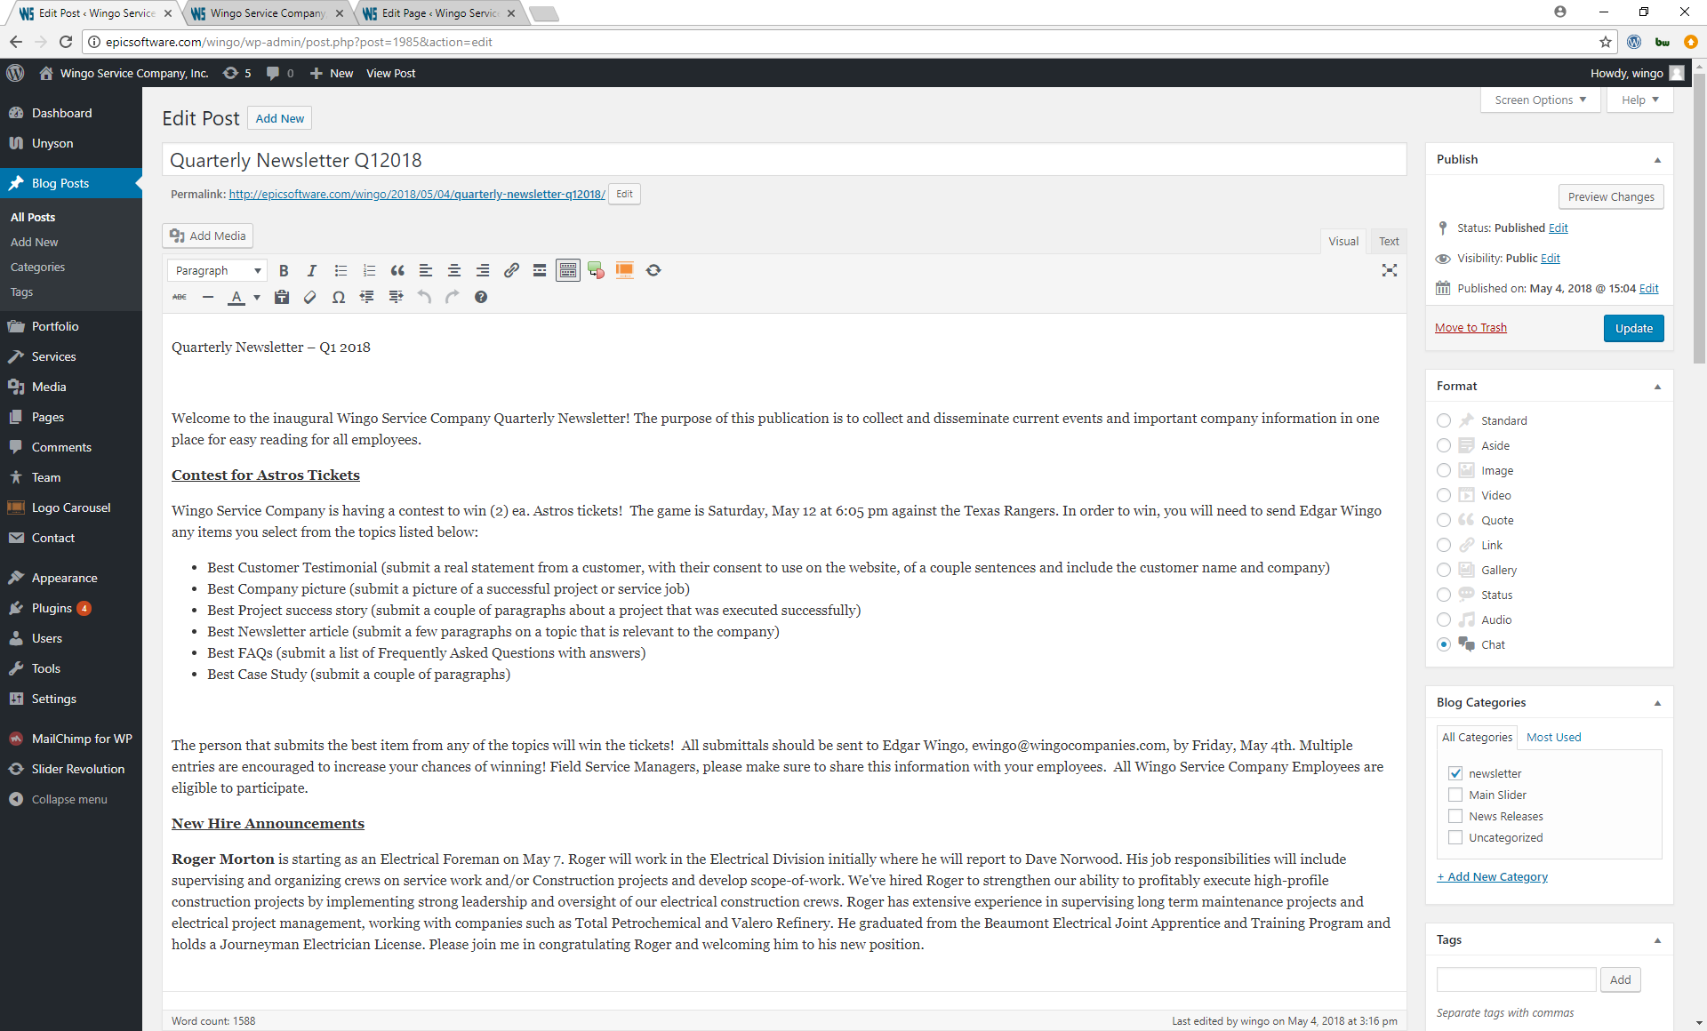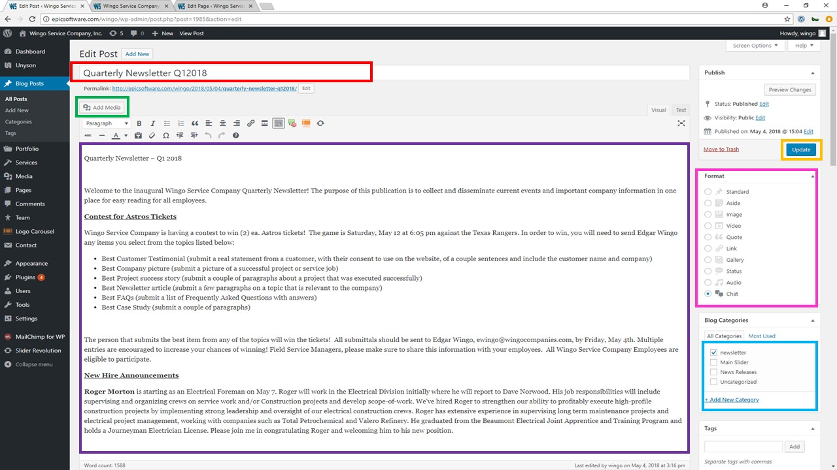

Explanation of the areas:

1. The red box is the title of the newsletter or news
2. The purple box is where all the content will go (See “How to use the text editor for WordPress”)
3. The green box is for adding images to the article
4. The pink box is for adding the format of the blog post.
5. The blue box is very important because it allows you to pick a category for your post between newsletter and news releases and that will determine in which page they will be shown.
6. The orange box which is the blue button, if your post hasn’t been published, will say publish, and if your updating an existing post will say update

After the blog is finished and published you will be able to see it on the News -> News Releases or News -> Newsletter pages

How to:

1. Update the “Privacy Statement” & “Terms And Conditions”
2. Update the FAQs page
3. Update the Case Studies Section in the homepage & how to create a new page for case studies
4. How to create a new campaign mailchimp (YT video)
5. How to log In
6. How to upload a picture
7. Importance of uploading the images with the right size
8. How to use the text editor for WordPress
9. How to add a new logo to the “Our customers section”
10. How to change the address of the map
11. How to change the social media links
12. How to upload new photos to the gallery (Media/Photos)
13. How to update the “Resources” pages: “Installation Guides”, “Industry Associations”, “Links”
14. How to update the job opportunities form
15. How to add more testimonials